**MODULE:1 :OVERVIEW OF IT INDUSTRY**

**LAB EXERCISE**

1. **Write a simple “Hello world” program in two different programming languages of your choice. Compare the structure and syntax.**

**Answer 1: here are two languages we are programming Python and C languages.**

**Python : print(“Hello, world”)**

**Structure and syntax : 1)Minimal: one line of code. (2)No need for setup: No explicit function or header declarations. (3)Interpreted language: runs directly without compilation.**

**C language :**

**#include<stdio.h>**

**Main() {**

**Printf(“Hello, world!!\n”);**

**}**

1. **Research and create a diagram of how data is transmitted from a client to a server over the internet?**

**Answer 2:**

**1.Client(Device/browser):role:The starting point where user sends a request, such as typing URL in a browser or clicking link.**

**Process: The user sends HTTP/HTTPS request containing URL and relevant headers. The device prepares the data packet with the destination domain name.**

**2.Router:Role: The router is the first network device that directs the client data packets towards its destination.**

**Process: 1)The router checks its routing table to determine the best path for the packet.2)The packet is sent to the ISP’s network for further processing.**

**3.ISP(Internet Service Provider): Role: The ISP provides internet access and acts as an intermediary between the client and the broader internet.**

**Process:1)The ISP receives the packet and checks if it has a cached DNS record for the request domain. 2)If the DNS record is not cached, it forwards the request to a DNS server. Here cached mean storing data temporary in the system when we send request system checks that for particular website ip address already saved or not if saved then it does not go to DNS(Domain Name Server) because it already know IP address so directly it goes to IP address. And if IP address of that website is not known then first it goes for it to DNS then come back with IP address. And then go to that address.**

**4.DNS Server :Role:Translates the domain name(**[**www.google.com**](http://www.google.com)**) into its corresponding IP address eg(142.250.190.14)**

**Process:1)The client sends a query to the DNS Server. 2)The DNS server responds with the Ip address of the destination server.3)The Ip address is then included in the data packet for the routing.**

**5.Internet Backbone: Role: The global network of high-speed routers and fiber-optics cables that transmits data across the internet.**

**Process:1)The ISP forwards the packets to the internet backbone.**

**2)The packet traverses multiple networks and routers to reach the destination servers network**

**6.Destination Server: Role:The server that hosts the requested resource (eg:webpage, file or API)**

**Process:1)The servers receives the request process it, and retrieves the requested resource (2) It prepares a response (eg:HTML content )**

**And sends it back to the client**

**7)Response Delivery:Role: The return flow of data from server to the client.**

**Process:1)The Server’s response packet travels back through the same path : Internet backbone 🡪 ISP 🡪 Router 🡪 Client.**

**2)The browser or application on the client devices processes the response and displays the content(rendering a webpage)**

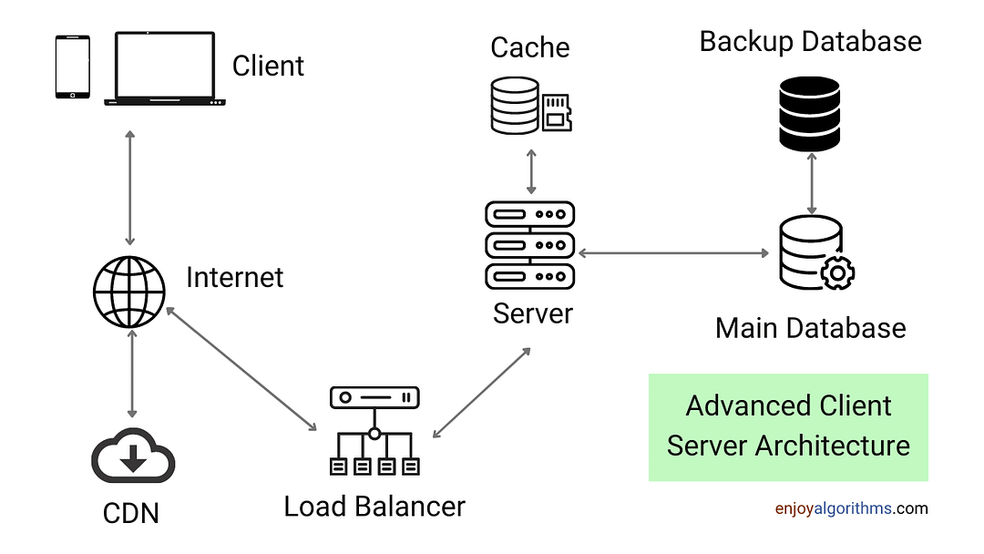

* **(4) Research different types of internet connections (e.g., broadband, fiber, satellite)and list their pros and cons?**
* **Answer 4 : 1)Broadband (DSL and Cable) :Description :Broadband refers to high-speed internet delivered through telephone lines(DSL) or coaxial cables (Cable)**

**Pros : 1)widely available in urban and suburban areas.**

**2)Relatively affordable compared to other options.**

**3)Reliable for streaming, browsing and light gaming.**

**Cons: 1)Slower speeds compared to fiber (2) Speed can decrease during peak hours (Cable) (3) DSL is distance sensitive :Far from the provider, slower is the speed;**

**2)Fiber Optic : Description : Fiber internet uses optical fibers to transmit data at the speed of light**

**Pros:1)Extremely high speed 2)low latency excellent for gaming and video conferencing 3)high reliability, even during peak usage times.**

**Cons : 1) limited availability, especially in rural areas. (2)Higher installation and subscription cost.**

**3.Satelite : Description :Internet provided through communication satelites, ideal for remote or rural areas**

**Pros: Available almost everywhere including rural and remote locations. 2)No dependency on physical cables or infrastructure.**

**Cons: 1)High latency due to distance signals must travel. 2)Limited data plans with high costs 3)susceptible to weather disruptions.**

**4)Mobile Data(3G/4G/5G) :Description :wireless internet provided via cellular networks, accessible on smartphones or through mobile hotspots.**

**Pros: portable and accessible wherever there is network coverage.**

**2)increasingly high speed 4G and 5G. 3)No need for physical connection.**

**Cons: 1)Data caps and throttling after exceeding limits 2)can be more expensive than fixed line connection.**

**5)Dial-up : Description : The earliest form of internet connection, using telephone lines.**

**Pros: 1)Extremely affordable 2)available whenever phone lines exist**

**Cons: 1)very low speed**

**6)Fixed wireless : Description : Uses radio signals to deliver internet to homes, often via a direct line-of-sight connection to a base station. Pros: 1)Good option for rural or underserved areas. 2)Faster installation compared to fiber**

**Cons:1)Susceptible to weather conditions and physical obstructions.**

**7)Hotspot (Public and private):Description :Internet access provided through wifi hotspot either in public space or via mobile device**

**Pros : Convinient and protable 2)No installation required for public hotspot**

**Cons: 1)Limited speed and coverage 2)Public hotspots can pose security risks.**

* **(5)** **: Identify and explain three common application security vulnerabilities. Suggest possible solutions?**
* **Answer : 1.SQL Injection : Explanation : 1)SQL Injections occurs when an attackers manipulates an applications database query by injecting malicious SQL code. (2) for example using “OR” “1”=1 in a login forms username field can bypass authentication (3)This vulneribity allows attackers to view, modify or delete sensitive data.**
* **Solutions : 1)Input validation : validate and sanitize all user inputs to prevent unexpected characters. 2)Prepared statements : Use parameterized queries or ORM frameworks like SQLAlchemy or hibernate to ensure SQL queries precompiled**
* **2: Cross-Site Scripting (XSS):Explanation :XSS occurs when malicious scripts are injected into web pages viewed by other users.2)for example attacker could inject <script> alert(‘hacked’);</script> into comment field. 3)this can lead to session hijacking, credential theft, or redirection to malicious websites. Solution : 1)Input Escaping :Escape special characters in user input before displaying it(eg: &, <,>). 2)Content Security Policy (CSP) : Configure a CSP to restrict the execution of scripts from unstructured sources.**
* **Question : 6:** **: Identify and classify 5 applications you use daily as either system software or application software?**
* **Answer : 6:**

**Software Name : Category : Reason**

**Operating System : System Software : Manage hardware**

**Web browser: Application Software : provides user specific**

**Word Processor : Application Software : Focused on document**

**Antivirus Software: System Software: works at the system**

**Messaging app: Application software : for communication**

* **Question 7 : : Design a basic three-tier software architecture diagram for a web application?**
* **Answer 7: 1.Presentation Layer(client/browser): Represents user interfaces like desktop, tablet, and smartphone**

**Application Layer : Consists of web servers and application servers managing business logic and processing requests.**

**Data layer: Feature the databases server and retrieving application data.**

* **Question 8: Create a case study on the functionality of the presentation, business logic, and data access layers of a given software system?**
* **Answer 8 : Case study : Online E-commerce Application :**

**Presentation Layer: functionality : The presentation layer is responsible for the user interface and interaction. It includes the website or mobile app where customers can browse products view details and make purchases.**

**Example scenario : A user opens the e-commerce app and searches for wireless headphones. The app displays a list of relevant products with prices and reviews**

**Key Technologies: Frontend Frame works : React.js, Angular, or vue.js. API Consumed : RESTful APIs provided by the business logic layer**